AWS Creating an Amazon CloudFront Distribution using Amazon S3

Adhvitha Sivaganesh| CCNP

Purpose:

In this lesson, I created an Amazon S3 bucket with a unique global namespace and learned how to create an Amazon CloudFront distribution. I learned how to deliver content and decrease the end-user latency using the CloudFront service. I did run into some issues when configuring the CloudFront Distribution since there were certain permission issues.

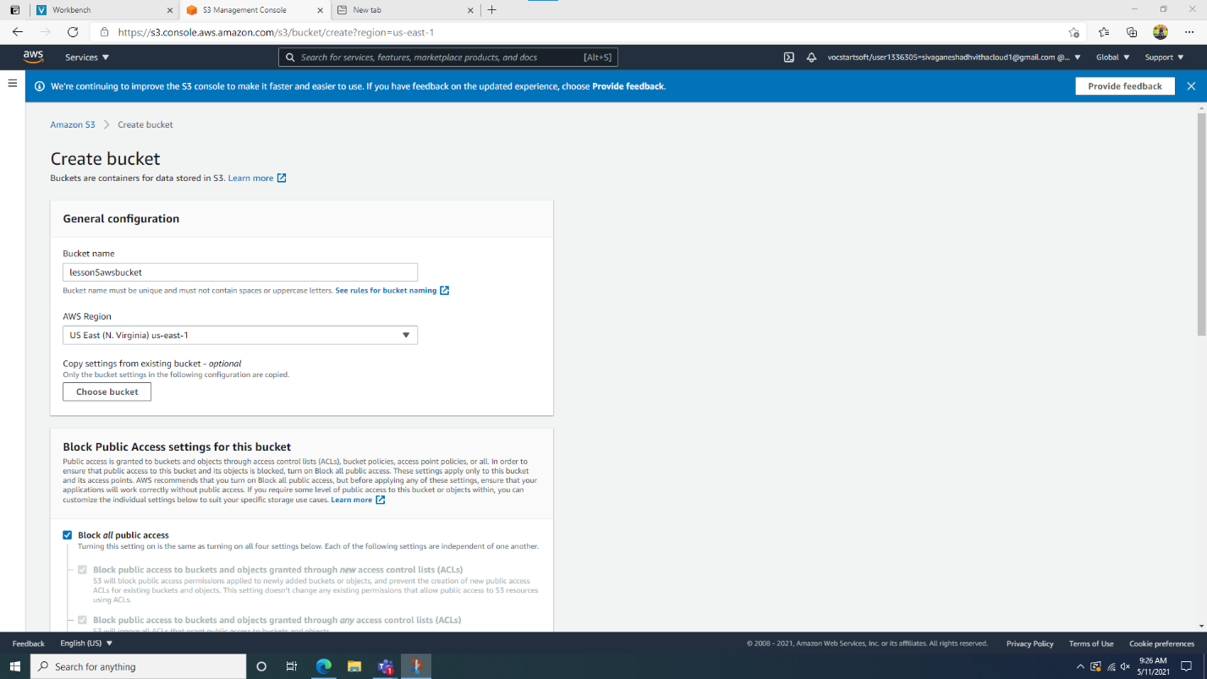

* At the start, I created a new bucket by going to the Amazon S3 console. The value was the CloudFront Acceleration and the key was name.

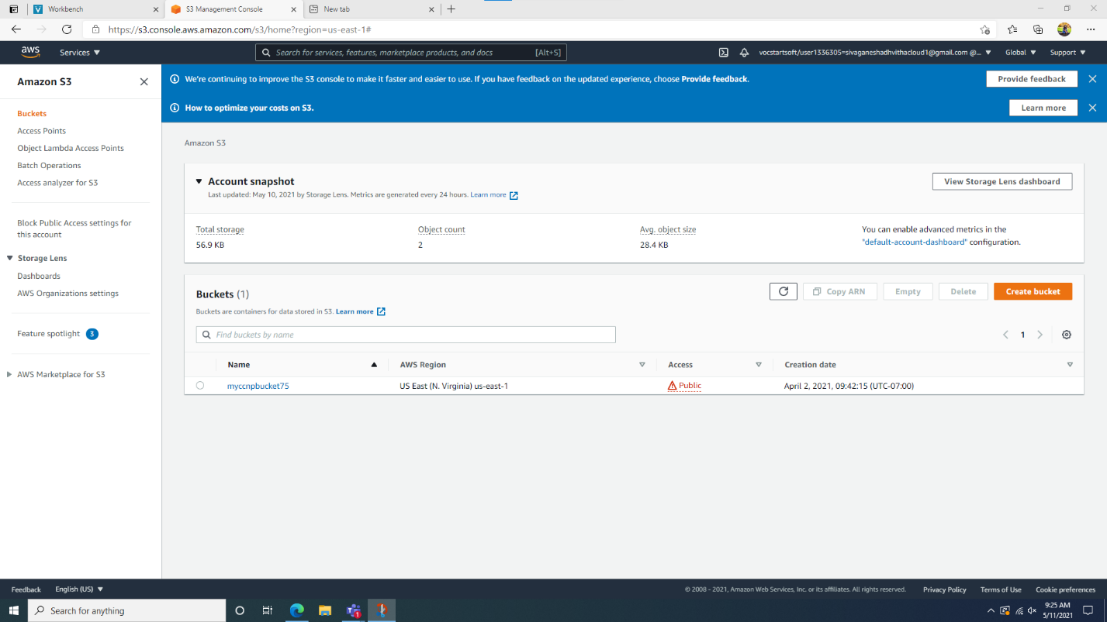

* This was the S3 bucket that I created with specific settings.

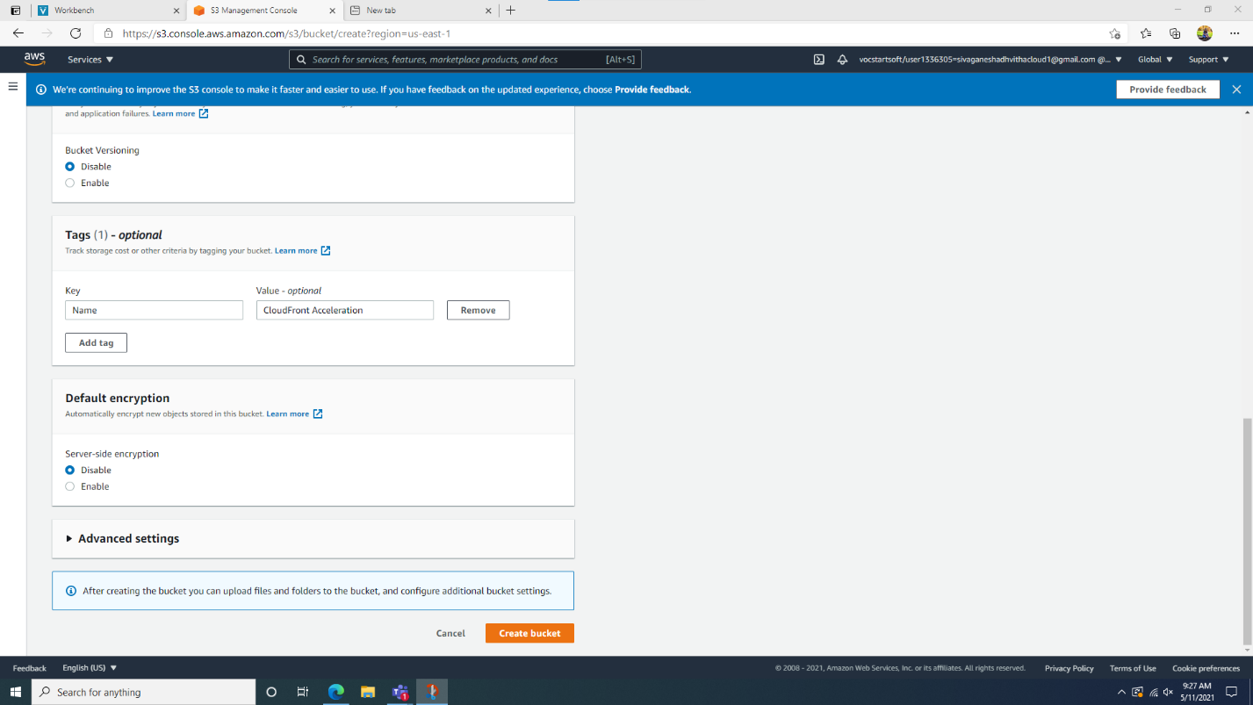

* After that, I went into the bucket and the permissions tab and deselected the “Block all public access” option

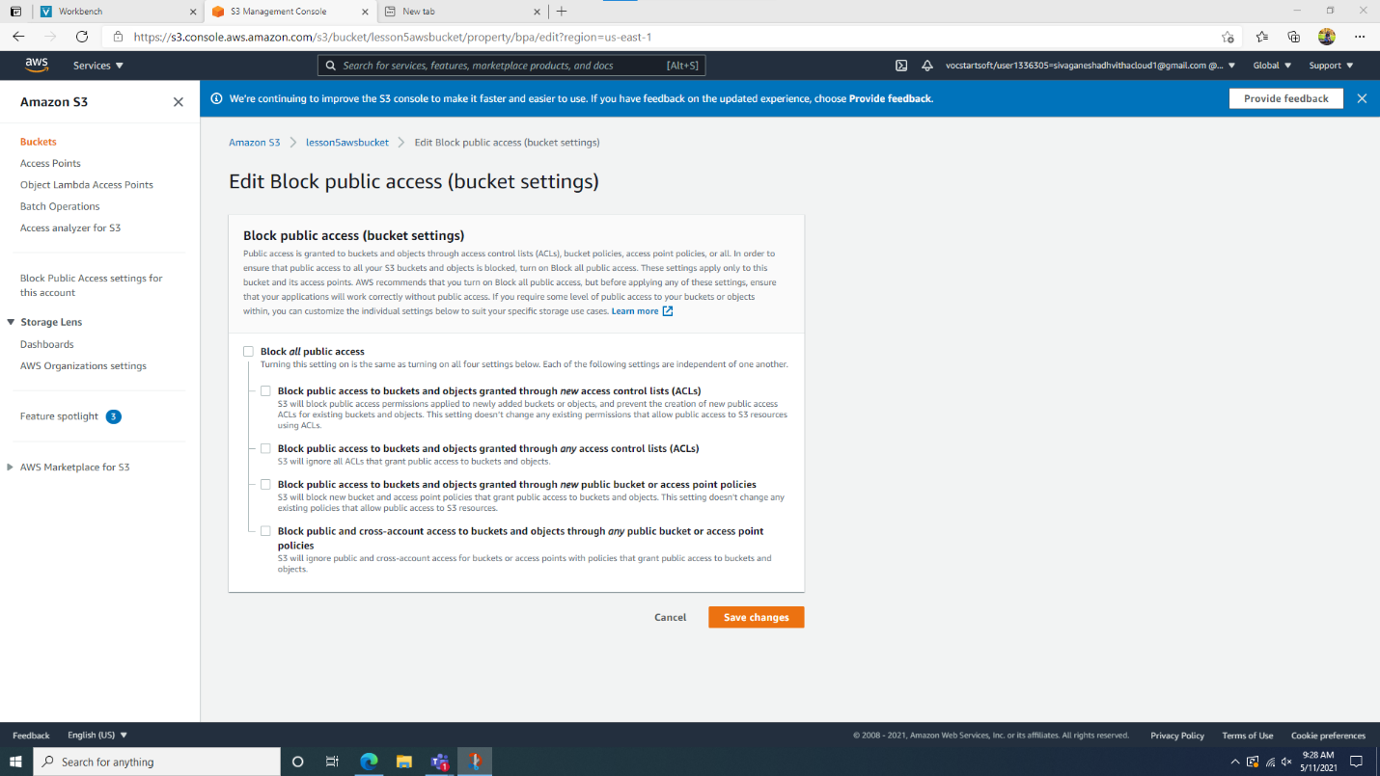

* I edited the public access settings on the bucket and saved the changes

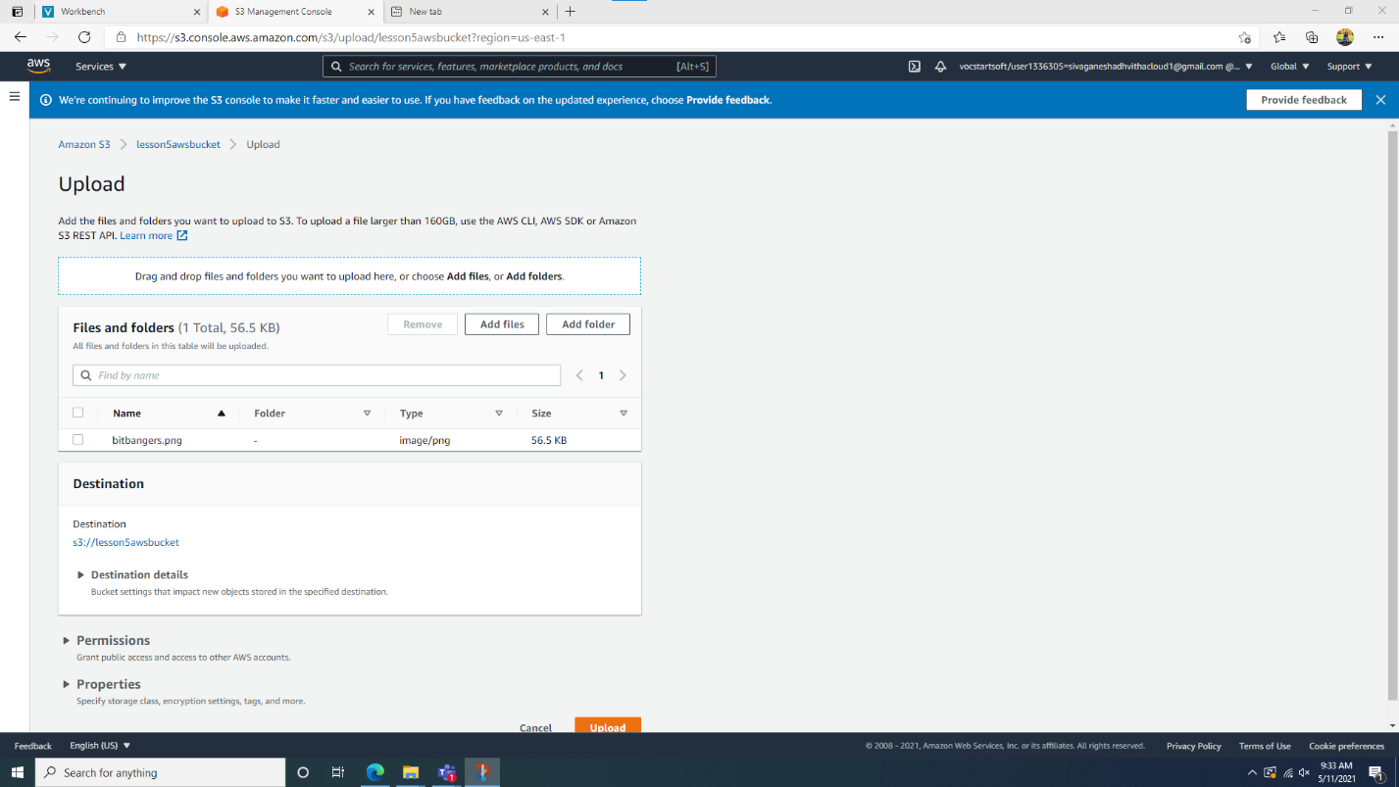

* Next, I navigated to a website to save specific files to the desktop. I selected the bitbangers.png and then uploaded that to the bucket.

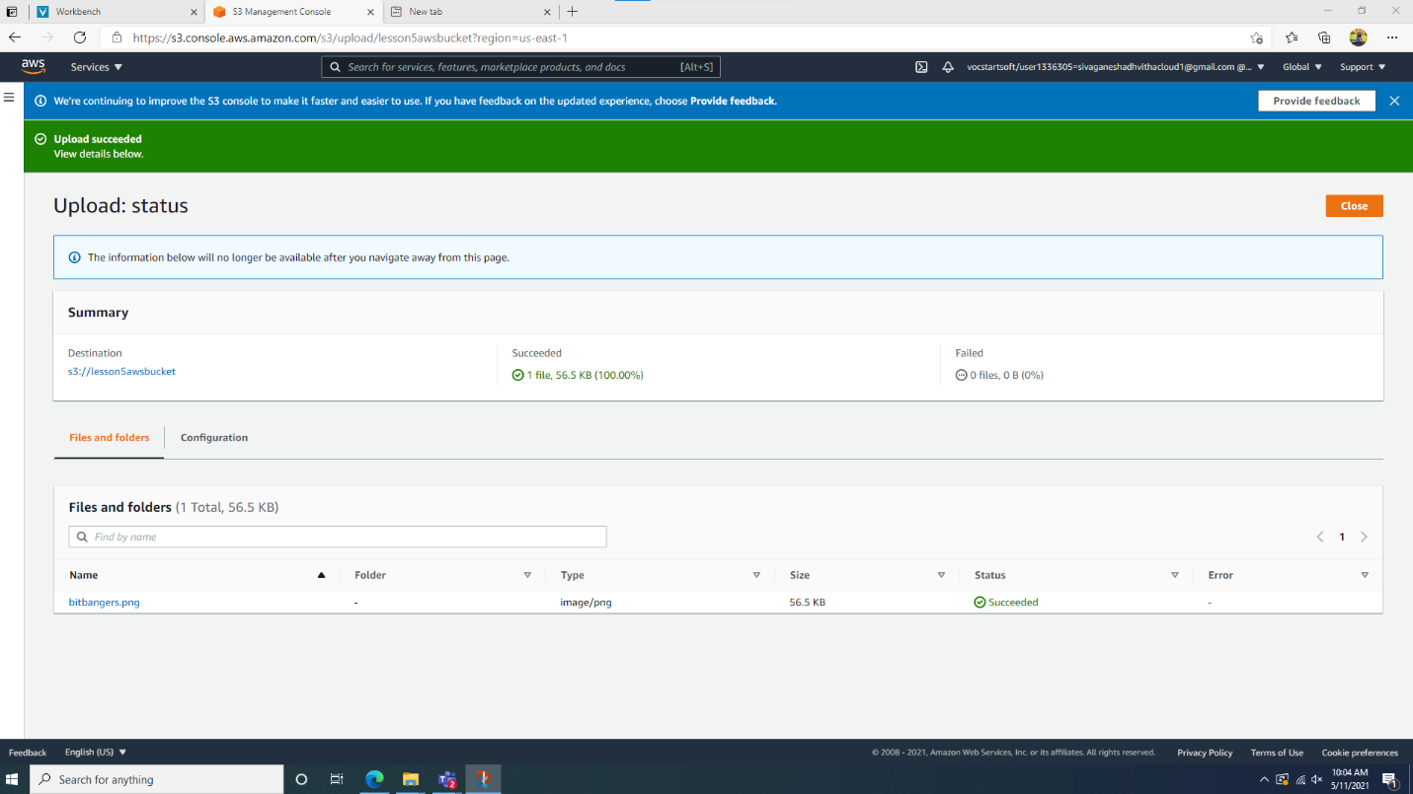

* I uploaded the bitbangers.png to the bucket

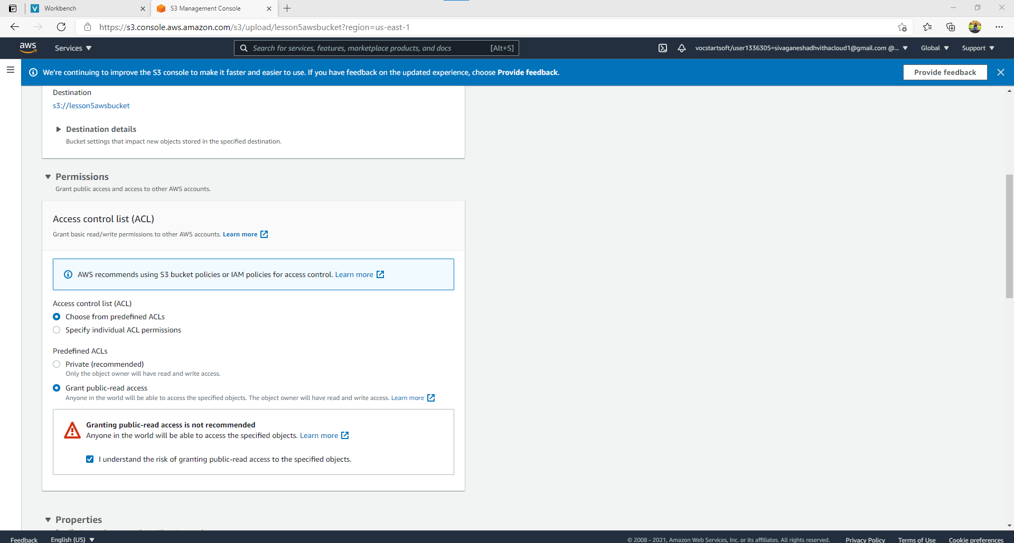

* Afterwards, I located the Manage public permissions option and granted public read access to the object

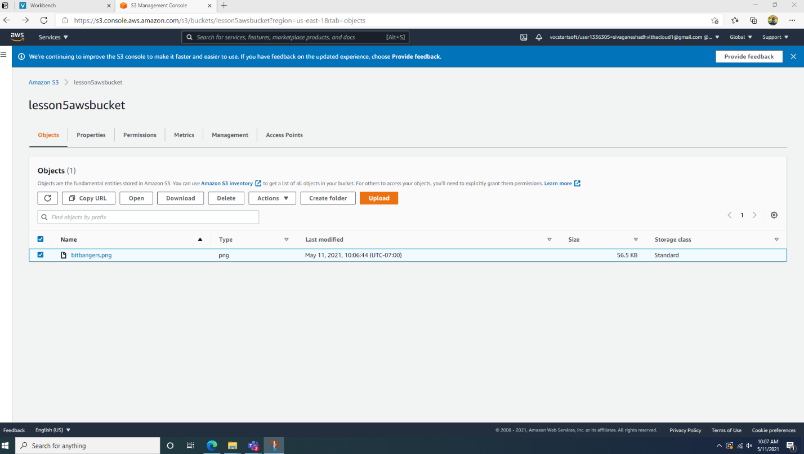

* I copied the name of the file to the text editor and the image was uploaded to the bucket.

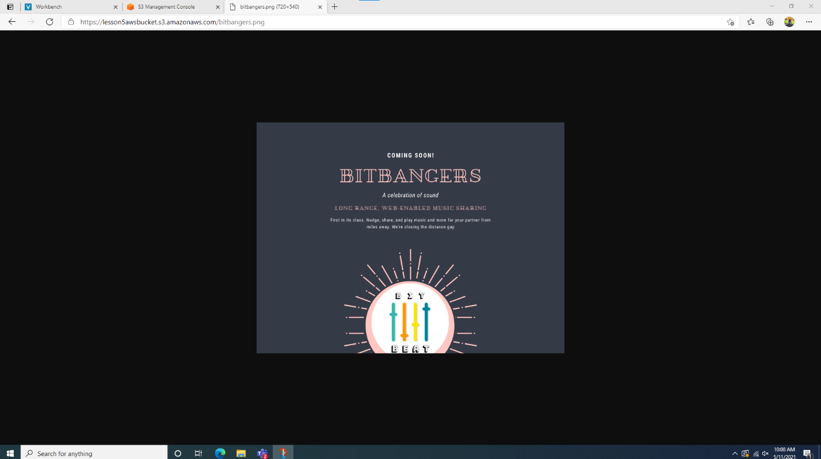

* I went to the overview section and located the object URL and copied and put it in the browser and it then displayed the image.

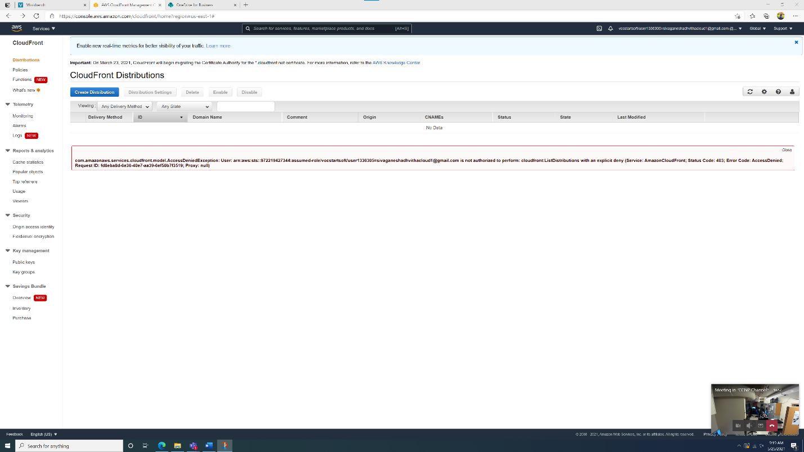

* Next, I went into the CloudFront console under the Network and Content Delivery category.

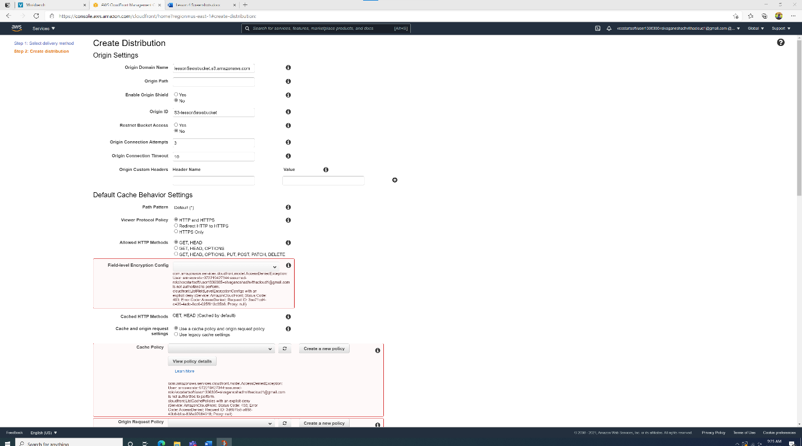

* I configured specific settings for the console and then clicked save and multiple errors popped up regarding permission to create the distribution.

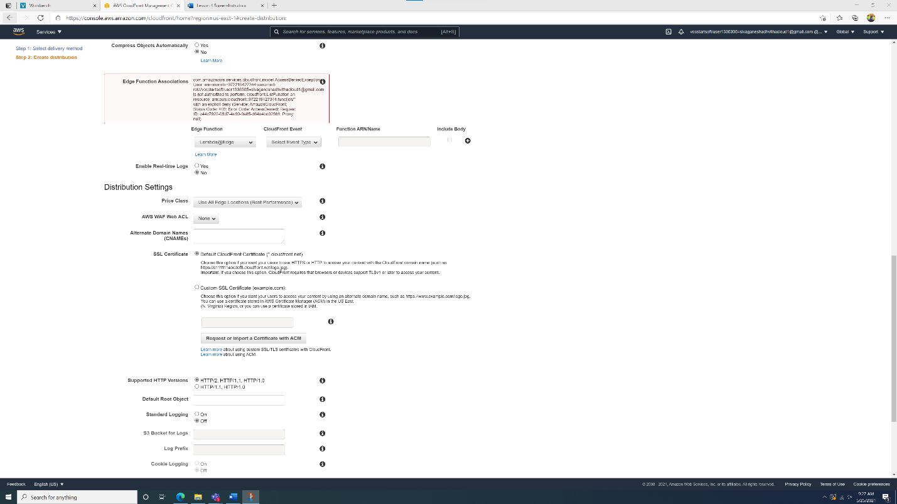

* These were the configurations I tried to set and the errors that came up after trying to save the CloudFront configuration.

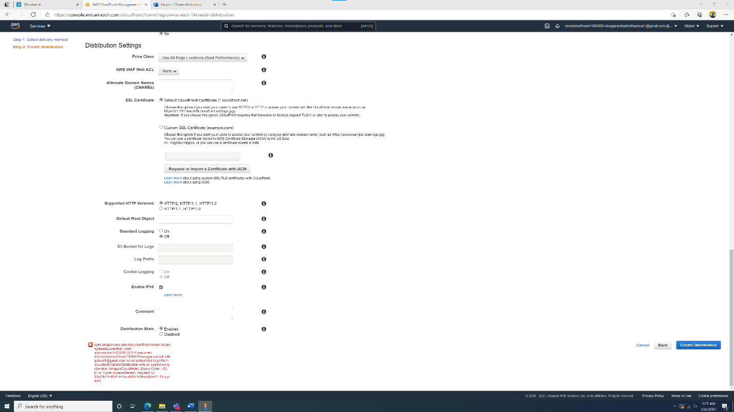

Problems:

In this lesson, I encountered issues when I was attempting to configure and create the Amazon CloudFront distribution. After the configuration with the distribution, I clicked save and many permission errors saying “AccessDenied” which is for the account that we use for AWS. I couldn’t completely configure the distribution because of the errors. Otherwise with the previous steps I was able to get to the BitBangers page within the bucket configurations.